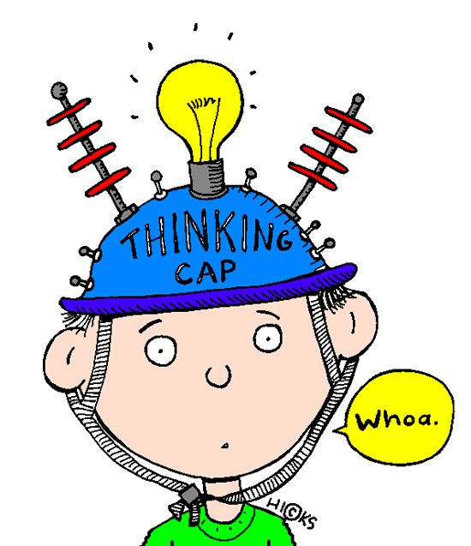 Inquiry for Gifted Students
Form 2
Annotated Bibliography: Record the search journey you undertake as you pursue your question. List the citation (APA 6) and record a brief description that you could employ in a slide or prezi and one that provides you with enough information to allow you to discriminate between multiple, similar citations. Add more frames as needed.
Pritchard, Gary (Nov 2, 2009). Strengths Based Learning. Retrieved from https://www.youtube.com/watch?v=Gve3ap-E8c0&t=10s
Focuses on finding strengths by asking what excites you.
Fox, Jenifer (Dec 26, 2007). Now Discover Strengths For Students. Retrieved from https://www.youtube.com/watch?v=3yxhRoyd86c
Affinity program – Jenifer Fox seems to be a key person in this research.
Fox, Jenifer (May 31, 2013). Encouraging Strengths in Our Children: Jenifer Fox at TEDxTraverseCity. Retrieved from https://www.youtube.com/watch?v=leuzYAId3Kg
She asks “WHY are we teaching kids?” – that’s key to improvement in education. She believes strengths are things we feel great about – see e-notebook
Alberta Learning (2004). Focus on Inquiry: A Teacher’s Guide to Implementing Inquiry-based Learning. Retrieved from https://hamline.learninghouse.com/pluginfile.php/119257/mod_page/content/2/focusoninquiry.pdf
Contains graphic handouts to help students determine strengths – see e-notebook
Padraig, M., McLoughlin, M.M. PhD (January 7, 2009). Inquiry-Based Learning: An Educational Reform Based Upon Content-Centred Teaching. Retrieved from https://hamline.learninghouse.com/pluginfile.php/119257/mod_page/content/2/Inquiry-based-Learning-An-Educational-Reform.pdf
The basic philosophical position is ‘if it works, then use it,’ to paraphrase William James. Uses Disney movies to prove point of strengths (see e-notebook)
Uplifting Content - Facebook (February 23, 2017). Powerful Short Film. Retrieved from https://www.facebook.com/pg/upliftingcontent/videos/ (February 23)
Closeted teen is abusive, and becomes racist, sad old man. Other teen, as well, does not recognize his own strengths, the essence of who they are.
SAI (2010). Strength Assessment Inventory. Retrieved from https://www.strengthassessment.ca/
- 124 questions to survey strengths – requires license fee
Desautels, Lori, Dr. (September 1, 2015). Creating Safe, Strength-Based Classrooms. Retrieved from https://www.edutopia.org/blog/creating-safe-strength-based-classrooms-lori-desautels
Great ideas for simply adding strengths and positivity to the classroom (5 ideas) see e-notebook
Rawana, E., Latimer, K., Whitley, J., and Probizanski, M. (November 2009). Strength-Based Classroom Strategies For Teachers from Canadian Teacher Magazine. Retrieved from
http://www.wellingtoncdsb.ca/school/stjohnbosco/publications/strength-based%20classroom%20strategies.pdf
concrete, daily “little” things that can be done to create a strength-based, positive environment. Already do many of these, but some good suggestions. See e-notebook
Costa, A.L, and Kallick, B. (2000). Discovering & Exploring Habits of Mind. Alexandria, VA: Association for Supervision and Curriculum Development
Rawana, E., Brownlee, K., Probizanski, M., Harris, H., & Baxter, D. Reshaping School Culture: Implementing A Strengths-Based Approach in Schools (September 16, 2014). Not in print. – will continue to look for it.
Ricci, Mary Cay (2013). Mindsets in the Classroom: Building a Culture of Success and Student Achievement in Schools. Waco, TX: Prufrock Press
Ricci, Mary Cay (2015). Ready-to-Use Resources for Mindsets in the Classroom: Everything Educators Need for School Success. Waco, TX: Prufrock Press
Madrigal, Stephanie (2008). Superflex: Superflex takes on Rock Brain and the Team of Unthinkables…A New Beginning. San Jose: Think Social Publishing
Rath, Tom (2007). Habits of Mind. New York: Gallup Press.
Rath,Tom, and Reckmeyer, Mary (2009) How Full is Your Bucket? For Kids
Winner, Michelle Garcia, and Crooke, Pamela (2008). You Are a Social Detective. San Jose: Think Social Publishing
Madrigal, Stephanie, and Winner, Michelle Garcia (2008). Superflex…A Superhero Social Thinking Curriculum. San Jose: Think Social Curriculum
Covey, Sean (2008). The 7 Habits of Happy Kids. New York: Simon & Schuster Books for Young Readers
Aker, Angie (2015, Dec 8). You may suffer from 'impostor syndrome.' Lots of smart people with signs of high achievement do. From Upworthy. Retrieved from http://www.upworthy.com/you-may-suffer-from-impostor-syndrome-lots-of-smart-people-with-signs-of-high-achievement-do?c=ufb8
This is the imposter syndrome article. Follow-up with listening to Carl Richards
Zaslove, Mira (July 15, 2015). Is it better to focus on your strengths or on your weaknesses? From Quora. Retrieved from https://www.quora.com/Is-it-better-to-focus-on-your-strengths-or-on-your-weaknesses
Cole, Nicolas (March 9, 2015). Is it better to focus on your strengths or on your weaknesses? From Quora. Retrieved from https://www.quora.com/Is-it-better-to-focus-on-your-strengths-or-on-your-weaknesses
Brill, Jonathan (July 8, 2015). Is it better to focus on your strengths or on your weaknesses? From Quora. Retrieved from https://www.quora.com/Is-it-better-to-focus-on-your-strengths-or-on-your-weaknesses
Altucher, James (September 25, 2012). Is it better to focus on your strengths or on your weaknesses? From Quora. Retrieved from https://www.quora.com/Is-it-better-to-focus-on-your-strengths-or-on-your-weaknesses
Brock, David (Oct 2, 2016). Focus on Your People’s Strengths, Not Their Weaknesses??? From Partners in EXCELLENCE Blog — Making A Difference. Retrieved from http://partnersinexcellenceblog.com/focus-on-your-peoples-strengths-not-their-weaknesses/
Byham, William C. Ph.D. (2009). Maximizing Strengths v. Fixing Weaknesses... Why Choose? From Development Dimensions International, Inc., Retrieved from http://www.ddiworld.com/ddi/media/articles/maximizingstrengthsvfixingweaknesseswhychoose_ar_ddi.pdf?ext=.pdf
McQuaid, Michelle, (January 15, 2017). Could Focusing on Strengths Ruin Your Career? From THE BLOG. Retrieved from http://www.huffingtonpost.com/michelle-mcquaid/could-focusing-on-strengths-ruin-your-career_b_8985172.html
Chamorro-Premuzic, Tomas (January 21, 2016). Stop Focusing on Your Strengths, from Harvard Business Review. Retrieved from https://hbr.org/ideacast/2016/01/stop-focusing-on-your-strengths.html
prateek rangineni (September 20, 2015). The Story of Yin Yang (video). Retrieved from
https://www.bing.com/videos/search?q=the+story+of+yin+yang&&view=detail&mid=B8703D60713D0C3183FDB8703D60713D0C3183FD&FORM=VRDGAR
Cartwright, Mark, (26 November 2012). Yin and Yang Definition. From Ancient History Encyclopedia. Retrieved from http://www.ancient.eu/Yin_and_Yang/
Bellaimey, John (Aug 2, 2013). The Hidden Meanings of Yin and Yang. From TED-Ed. Retrieved from https://www.youtube.com/watch?v=ezmR9Attpyc
Jessica (December 10, 2009). Yin-Yang: A Taoist Symbol. From EssaysForStudent. Retrieved from https://www.essaysforstudent.com/essays/Yin-Yang-A-Taoist-Symbol/23134.html
Muth, Jon J (2005). Zen Shorts. New York, NY: Scholastic Inc.
Muth, Jon J (2002). The Three Questions: Based on a Story by Leo Tolstoy. New York, NY: Scholastic Inc.
Silverstein, Shel (1964). The Giving Tree. New York, NY: Harper & Row
Young, Ed (1992). Seven Blind Mice. New York, NY: Scholastic Inc.
Morrison, Toni (1999). The Big Box. New York, NY: Hyperion Books
Lightman, Alan (1993). The Laters and the Nows. Einstein’s Dreams (p. ) London: Vintage
Basso, Bob (2003). Spill Your Guts! The Ultimate Conversation Game. Kansas City: Andrews McMeel Publishing
Azusa Pacific University (2017). What is the History of the Strengths Movement? Retrieved from http://www.apu.edu/strengthsacademy/movement/history/
JD (2008). The Strengths Movement. Retrieved from http://sourcesofinsight.com/the-strengths-movement/
JD (2008). Find Your Strengths. Retrieved from http://sourcesofinsight.com/finding-your-key-strengths/
Hargrove, Taryn (2016). The Big Box: Guidelines for Philosophical Discussion. From Teaching Children Philosophy. Retrieved from https://www.teachingchildrenphilosophy.org/BookModule/TheBigBox
Winter, Ariel S. (September 14, 2010). TONI MORRISON: THE BIG BOX. From We Too Were Children, Mr. Barrie. Retrieved from http://wetoowerechildren.blogspot.com/2010/09/toni-morrison-big-box.html
Resources to look at in the future (out of time)
Go Put Your Strengths to Work: 6 Powerful Steps to Achieve Outstanding Performance Hardcover – March 6, 2007
by Marcus Buckingham
Now, Discover Your Strengths Kindle Edition
by Marcus Buckingham (Author), Donald Clifton (Author) – However, this is probably just a StrengthsFinder 1.0 – Rath talks about it in his book

