Edutopia
By Laura Lee
March 5, 2020
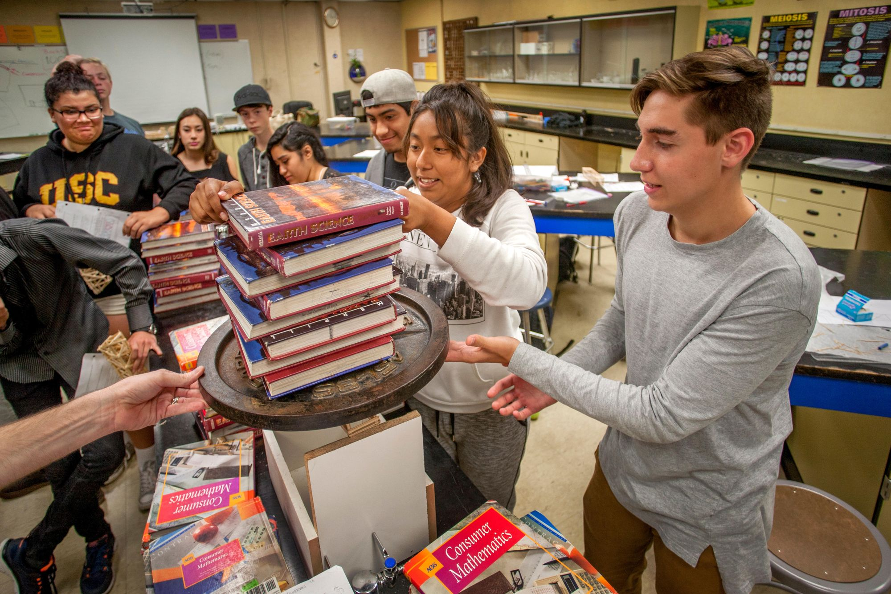
Marmaduke St. John/Alamy Stock Photo (17)
Group work can be a highlight of a class or a pain point for students and teachers alike. Cult of Pedagogy’s Jennifer Gonzalez examines the many challenges of group work in her post “Make Cooperative Learning Work Better.” Two key questions emerge for Gonzalez: First, is group work worth doing? And second, “how do we solve some of the most common problems with cooperative learning?”

Collaboration helps students “make greater academic and social gains” than when they work on their own, Gonzalez concludes, citing a paper that pulls together several meta-analyses that collectively cover more than 400 research studies. It is also a crucial way to counterbalance the influence of devices that are “stunting our ability to have regular conversations and robbing us of all the gifts that come with those interactions,” she writes. After establishing the value of group work, Gonzalez offers these tips for implementation:

Make the workload fair: In group work settings, one student often does the majority of the work. The problem is twofold: First, students don’t have the necessary skills for collaboration. “Teach these skills in the same way that you’d teach academic material,” Gonzalez advises. Model the type of cooperation you hope to see, and ask students to practice first on small projects before moving to bigger ones.

The second problem is structural—the task “has not been structured for true collaboration.” Gonzalez shares a variety of valuable solutions for this, including the classic jigsaw method.

Another way to make sure the workload is fairly shared is to establish ground rules for group work through contracts that allow student teams to decide on their parameters and codify their expectations in a written agreement.
Manage interpersonal dynamics: Solid collaboration requires that students feel comfortable with each other. Team members must interact in ways that “help, support, and encourage each other,” Gonzalez says.

Foster a classroom culture of support by setting up team-building activities at the outset that aren’t necessarily academic. Build on that by surveying students before and during group work to find out what’s working, what isn’t, and what changes they might make in the future. Engage with students to understand their perspectives on what makes a group successful.

Teaching students how to communicate and resolve conflicts cannot only help build their social and emotional skills but also improve the overall quality of collaborative work.

Keep students focused: “Whether it’s excessive talking, inappropriate device use, or general fooling around, a lot of cooperative time can be wasted when students just aren’t doing the work they’re supposed to be doing,” Gonzalez writes. Set specific, immediate goals, and use a timer to keep students on task. Check in with students throughout a project, at announced intervals, not only on the work but on how the collaboration is going.

Plan for absences: Advanced planning for possible absences can help teachers avoid a common pitfall of collaborative learning. “Design projects where some components require all group members’ participation, but others are done by individuals and might even be considered ‘like to have’ rather than ‘must have,’” Gonzalez says. If students sign a group contract, consider recommending that they include a contingency plan for absences.

Think about the ways technology can bridge the gap if a student is absent for more than one class period. If students use a shared platform, such as Google Drive, the absent student may be able to continue to contribute. If a student is out for several days, consider using video chat technology to connect them to their group.

